1. Introduction
This project, Digital Wallet Transaction Analysis Dashboard, aims to analyse and visualize digital payment transactions to understand user behaviour, payment preferences, and overall sales performance. The dashboard was created using Power BI to transform raw transaction data into meaningful insights through interactive visualizations and key performance indicators (KPIs).
2. Objective
The main objectives of this project are:
- To analyze transaction data across different payment methods, categories, and locations.
- To identify trends and patterns in digital payments over time.
- To create an interactive dashboard that supports data-driven business decisions.
3. Dataset Description
The dataset was obtained from Kaggle and refined in Excel before importing into Power BI. It contains 5,000 transaction records from the years 2023 and 2024.
Key Fields:
Field Name | Description
Transaction ID | Unique ID for each transaction
Transaction Date | Date of payment (2023–2024)
Product Amount | Total amount of the transaction
Product Category | Type of product/service
Payment Method | UPI, Credit Card, Debit Card, Wallet, etc.
Location | Urban, Suburban, or Rural area
Merchant Name | Vendor or platform where payment was made
Transaction Fees | Fee charged per transaction
Transaction Status | Successful, Pending, or Failed

4. Tools and Technologies
Tool | Purpose
Microsoft Excel | Data cleaning and preprocessing
Power BI | Dashboard design and visualization
DAX (Data Analysis Expressions) | Used for creating calculated measures

5. Data Processing
The data underwent several preprocessing steps before visualization:
- Removal of null and duplicate values.
- Standardization of date and currency formats.
- Conversion of transaction amounts to numeric fields.
- Categorization of data based on payment method, location, and transaction status.
6. Dashboard Design
The dashboard was created in Power BI Desktop, featuring KPIs and visuals that provide an overview of the digital wallet transactions.
Key Performance Indicators (KPIs):
- Total Sales: ₹24.79M
- Total Transactions: 5,000
- Monthly Sales Trend: Displays sales trends over time to observe fluctuations.

Dashboard Visuals:
- KPI Cards: Show total transactions and total sales.
- Pie Chart: Visualizes Sales by Category to identify top-performing categories.
- Line Chart: Displays Monthly Sales Trends for 2023–2024.
- Bar Chart: Shows Total Sales by Location (Urban, Suburban, Rural).
- Transaction Status Chart: Highlights successful, pending, and failed transactions.
- Table: Displays detailed merchant-wise performance and transaction fees.
- Filters (Slicers): Allow users to filter by Product Category, Payment Method, Month, and Year.
7. Dashboard Snapshot
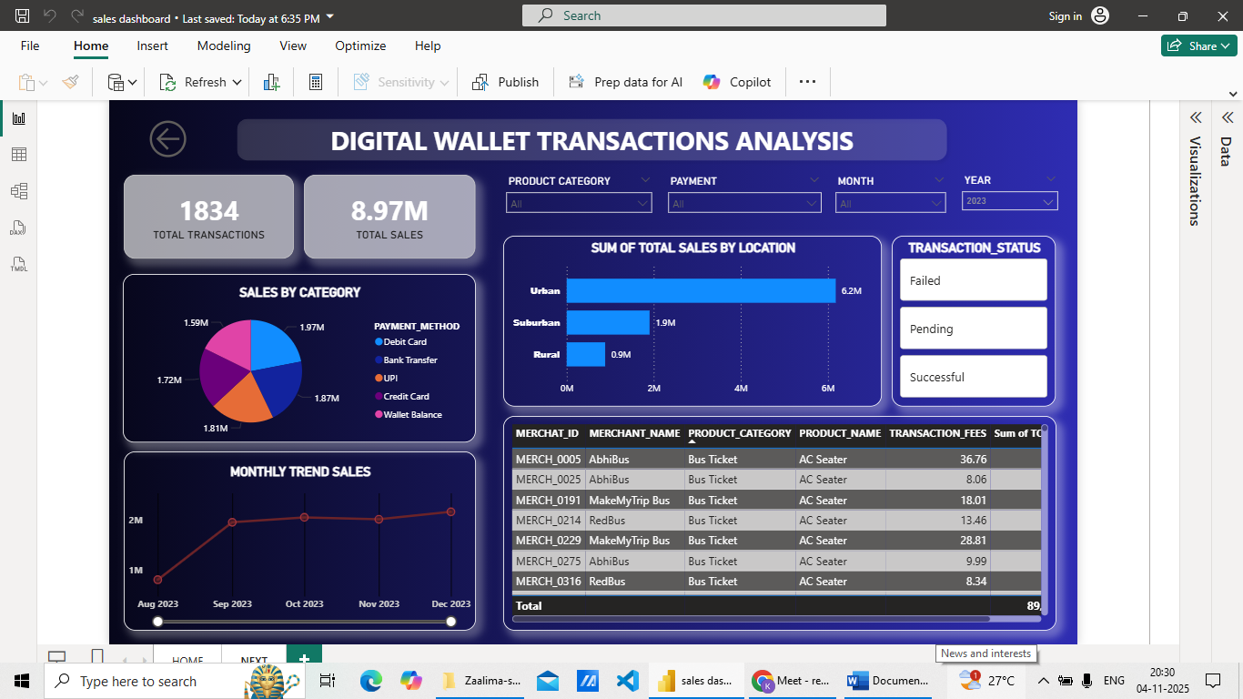
8. Insights
- Urban regions contributed the highest sales, indicating greater digital payment adoption in cities.
- Bus ticket transactions generated the maximum revenue among all product categories.
- UPI and credit card payments were the most preferred transaction methods.
- Sales trends remained stable throughout 2023–2024 with consistent monthly performance.
- Most transactions were successful, reflecting reliability in digital payment processing.
- The overall sales volume of ₹24.79M across 5,000 transactions highlights strong user engagement.

9. Conclusion
The Digital Wallet Transaction Analysis Dashboard effectively visualizes the overall digital payment ecosystem. It simplifies complex transactional data into understandable metrics, allowing businesses to decisions. The dashboard’s visual insights help identify profitable areas, understand payment preferences, and enhance business strategies for growth.
10. References
Kaggle Dataset: Digital Wallet Transactions

